iOS

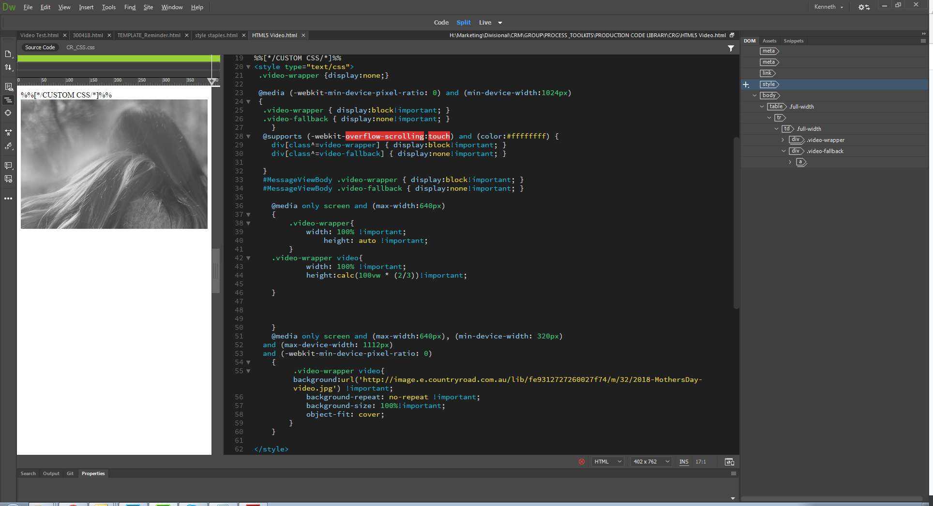

Change this CSS to the URL of the iOS image (no play button version)

Adjust this section to match the aspect ratio of the video (<https://andrew.hedges.name/experiments/aspect_ratio/>)  
e.g. for a 16:9 video change the value from 100vw \* (2/3) to be 100vw \* (9/16)

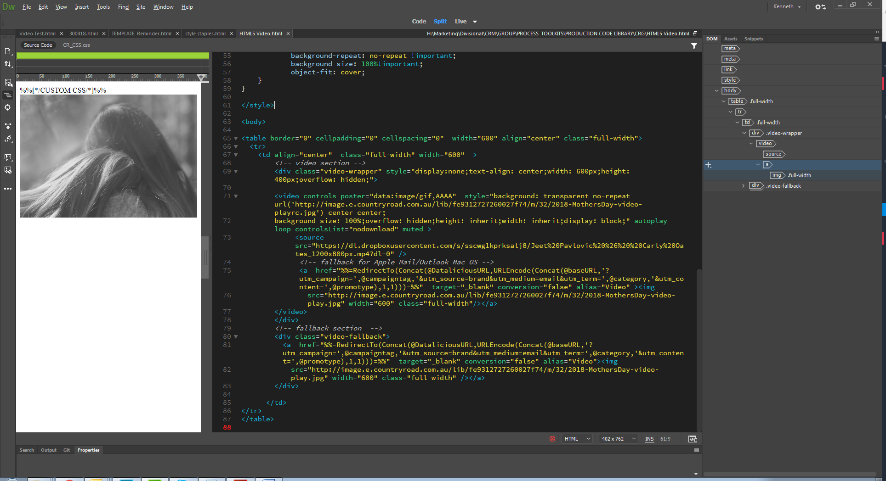

Change Image SRC to play image and change a href to video location (for fallback)

Change Image SRC to play image and change a href to video location (for fallback)

Set video source

Change CSS URL to Apple Mail/Outlook Mac image (right click to play image)

Adjust width/height to match video size (e.g. 1280x800px video is width:600px height:400px